Telecom Customer Churn Prediction System
End-to-End ML Project Documentation

Version 3.0 | June 2026

1. Project Overview

This project delivers a production-ready machine learning system for predicting customer churn in the telecommunications industry. It combines a trained predictive model, a REST API backend, an interactive analytics dashboard, and a customer-facing retention portal — all integrated into a coherent, deployable solution.
The system empowers retention teams to proactively identify at-risk customers, understand the root causes of churn, and take timely action to reduce revenue loss.

Metric | Value
Total Customers Analyzed | 7,043
Overall Churn Rate | 26.5%
Average Customer Lifetime Value (CLTV) | $4,400
Average Customer Tenure | 32.4 Months
Average Monthly Charges | $64.76
Optimal Risk Threshold | 0.2941
API Endpoint | https://telco-churn-api-gbyx.onrender.com

2. System Architecture & Component Order

The project is structured as a 4-layer architecture. Below is the logical flow from data science to end-user, with each component building on the previous.

Step | Component | Technology | Purpose
1 | ML Model & Backend API | FastAPI + Python (Render) | Trained 18-feature churn model served via REST API
2 | API Health Verification | Postman / Browser | Confirms the prediction endpoint is live and responding
3 | Analytics Dashboard | Plotly Dash (Render) | Exploratory analysis of churn drivers across the customer base
4 | Retention Portal | Streamlit | Front-end for CSRs to assess individual customer churn risk

3. Component-by-Component Explanation

3.1 — ML Model & Backend API (Foundation Layer)
The core of the system is a machine learning model trained on 18 engineered features derived from the IBM Telecom Customer Churn dataset. The model predicts two outputs per customer:
- Churn Probability — a continuous score from 0 to 1
- Risk Tier — categorized as Low Risk, Medium Risk, or High Risk based on the optimal threshold of 0.2941
- Assigned Cluster — an unsupervised segment (K-Means) grouping the customer with similar profiles

API Endpoint Details
Property | Detail
Base URL | https://telco-churn-api-gbyx.onrender.com
Prediction Endpoint | POST /predict
Health Check | GET / → {"message": "Telco Churn API Running"}
Response Format | JSON: assigned_cluster, churn_probability, churn_risk_flag, risk_tier
Hosting Platform | Render.com (free tier, auto-deploys from GitHub)
Response Time | ~671ms average

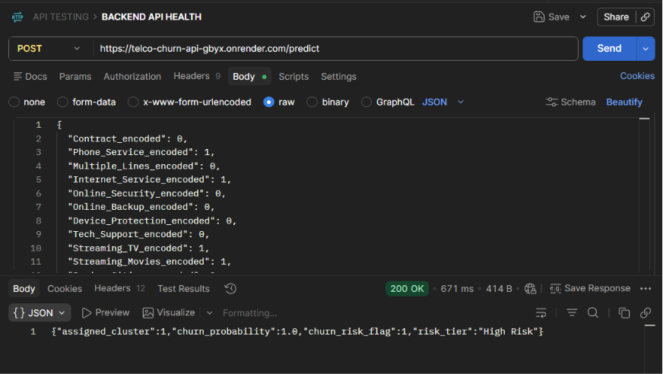

3.2 — API Health Verification (Validation Layer)
Before connecting the front-end tools, the API is validated using both a browser GET request and a Postman POST request with a sample payload.

Browser Health Check (Screenshot 2 — Image 2)
- URL visited: telco-churn-api-gbyx.onrender.com
- Response confirms the service is live: {"message": "Telco Churn API Running"}
- This is the GET / health-check route, confirming the server is up before any ML calls are made
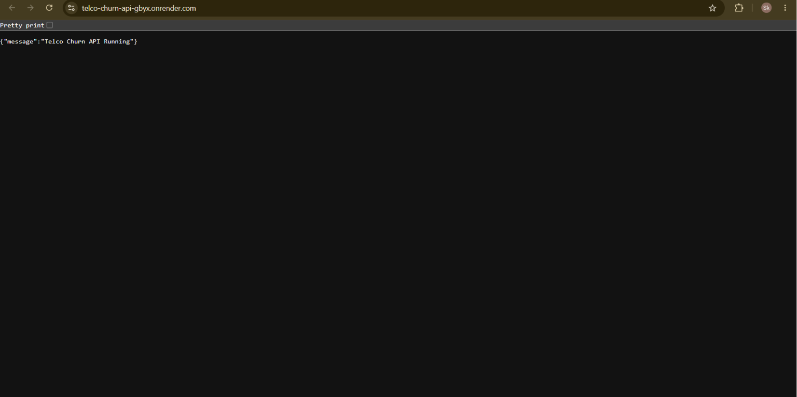
Postman Prediction Test (Screenshot 1 — Image 1)
- Method: POST to /predict with a JSON body containing 18 encoded feature fields
- HTTP Status: 200 OK — confirming successful prediction
- Sample Response: {"assigned_cluster": 1, "churn_probability": 1.0, "churn_risk_flag": 1, "risk_tier": "High Risk"}
- This test validates the full ML pipeline — from feature input through model inference to JSON output

The sample payload in the screenshot uses encoded categorical features (e.g., Contract_encoded: 0 = Month-to-month, Internet_Service_encoded: 1 = DSL). A churn probability of 1.0 with High Risk classification indicates this test customer has all the hallmarks of a churner.

3.3 — Customer Churn Analysis Dashboard (Insights Layer)
The Dash-based analytics dashboard (hosted on Render at telco-churn-api-1.onrender.com) provides interactive exploration of churn patterns across the entire customer base. Three snapshots demonstrate its filtering capabilities:

Dashboard View 1 — All Customers
KPI | Value
Total Customers | 7,043
Churn Rate | 26.5%
Average CLTV | $4,400
Average Tenure | 32.4 months
Avg Monthly Charges | $64.76

Top churn reasons globally: Attitude of support person (192), Competitor offered higher download speeds (189), Competitor offered more data (162), and Don't know (154). The CLTV vs Churn Score scatter plot reveals that high churn scores cluster heavily among customers with churn scores above 40.

Dashboard View 2 — Los Angeles Filter
KPI | Value
Filtered Customers | 305
Churn Rate | 29.5% (+3% above average)
Average CLTV | $4,377
Average Tenure | 30.8 months
Avg Monthly Charges | $62.42

Filtering to Los Angeles reveals a higher-than-average churn rate of 29.5%. Competitive offers dominate churn reasons in this city: higher download speeds (12 churners), more data (11), better devices (9), and a better overall offer (9).

Dashboard View 3 — Los Angeles, Non-Senior, No Partner
KPI | Value
Filtered Customers | 132
Churn Rate | 37.9% (highest segment)
Average CLTV | $4,232
Average Tenure | 21.2 months (shortest)
Avg Monthly Charges | $58.43

Narrowing to non-senior citizens with no partner in Los Angeles surfaces the highest-risk segment: 37.9% churn rate with the shortest average tenure (21.2 months). This represents young, independent, cost-sensitive customers who are most likely to switch to competitors. The OLS trendline on the scatter plot shows a slight negative CLTV-Churn Score correlation (R² = 0.0084), confirming that higher churn scores weakly predict lower lifetime value.

3.4 — Telecom Retention Portal v3.0 (Action Layer)
The Streamlit-based Retention Portal (hosted at telco-churn-api-amf2jey38hegcsrslwk2j9.streamlit.app) is the operational front-end used by Customer Service Representatives (CSRs) to evaluate individual customers in real time.

Portal Input Sections
Section | Fields Collected
Customer Demographics | Senior Citizen status, Partner status, Dependents
Geographic Footprint | City, Market Frequency, Share metrics
Core Services & Contracts | Contract Type, Internet Service Type, Phone Line, Multiple Lines
Security & Entertainment Add-ons | Online Security, Online Backup, Device Protection, Tech Support, Streaming TV, Streaming Movies
Financial & Tenure Drivers | Tenure (0–72 months), Monthly Bill Charges, Total Lifetime Charges

How It Works
- CSR enters the customer's profile across the 5 input sections above
- Portal calls the backend API (POST /predict) with the 18 encoded features
- API returns: churn probability, risk tier (Low/Medium/High), and cluster assignment
- Portal displays the risk assessment and recommended retention actions
- The optimal threshold of 0.2941 is applied server-side — customers above this score are flagged for intervention

The sample shown in the PDF represents a Month-to-month customer with no internet service, 12 months tenure, $65/month charges, and $780 total charges — a profile that would generate a real-time churn risk score from the ML model.

4. Key Business Insights

Insight | Finding | Implication
Primary Churn Driver | Competitor advantages (speed, data, devices) | Benchmark against top 3 competitors quarterly
Highest-Risk Segment | Young, non-senior, no-partner LA customers (37.9% churn) | Target with loyalty discounts and upgrade offers
Churn & Tenure | Shortest tenure (21.2 months) in high-churn segments | Focus retention efforts in first 24 months
Month-to-Month Risk | Month-to-month contracts dominate churn cases | Incentivize annual/2-year contract upgrades
Support Quality | Attitude of support person is the #1 churn reason overall | Invest in CSR training and quality monitoring
CLTV at Risk | Average CLTV of $4,400 per churned customer | Each percentage point reduction saves ~$31K per 100 customers

5. Technology Stack Summary

Layer | Technology | Role
Machine Learning | Python (scikit-learn, XGBoost) | Model training, feature engineering, clustering
API Backend | FastAPI + Uvicorn | Serve predictions via REST endpoint
API Hosting | Render.com | Cloud deployment with auto-scaling
Analytics Dashboard | Plotly Dash | Interactive data exploration UI
Retention Portal | Streamlit | CSR-facing risk assessment tool
Portal Hosting | Streamlit Community Cloud | Free hosting with GitHub integration
API Testing | Postman | Endpoint validation and payload testing
Data Source | IBM Telco Customer Churn Dataset | 7,043 customer records
6.DRAW BACKS OF PROJECT
1. Render Free Tier Cold Starts — Both the FastAPI backend and Plotly Dash app spin down after 15 minutes of inactivity, causing 30–60 second wake-up delays that make the system feel broken to first-time users.
2. Joblib/.pkl Load Latency — Model artifacts are deserialized from disk into memory on every cold start, adding extra seconds on top of Render's spin-up time and compounding the initial response delay.
3. Streamlit → API Timeout Risk — Streamlit uses a short default request timeout, so if the API hasn't fully woken up when a CSR submits a customer profile, the request silently fails or throws an unhandled error with no user feedback.
4. No Caching Layer — Every prediction triggers a full API round-trip with fresh model inference. Repeated queries for the same customer profile recompute from scratch, wasting latency that a simple Redis or in-memory cache could eliminate.
5. Single Point of Failure — The entire Streamlit portal depends on one Render-hosted API endpoint with no fallback, retry logic, or graceful degradation — if the API is down, the portal is completely non-functional.
6. AI-Assisted Development Gaps — Heavy reliance on ChatGPT and Gemini for prompt-driven code generation, without deep manual review, can introduce subtle bugs in feature encoding or threshold logic that are hard to catch without rigorous unit tests.
7. No Real-Time Data Pipeline — The dashboard and model run on a static dataset snapshot; there is no live data ingestion, so churn predictions become stale as customer behavior evolves post-deployment.
8. Free Tier Resource Ceiling — Render and Streamlit Community Cloud impose strict memory and CPU limits, meaning the system cannot handle concurrent users or larger datasets without hitting resource caps and crashing.

7. End-to-End Flow Summary

The complete project workflow follows this sequence:

- Step 1 — Data & Model: Raw telecom data is cleaned, features are engineered, and an ML model is trained to predict churn probability.
- Step 2 — API Deployment: The model is wrapped in a FastAPI app and deployed to Render.com, exposing a /predict endpoint.
- Step 3 — Health Check: The API is validated via browser (GET /) and Postman (POST /predict) to confirm it is live and returning correct predictions.
- Step 4 — Dashboard: The Dash analytics portal connects to the dataset to provide business-level churn insights, filterable by city, demographics, and partner status.
- Step 5 — Retention Portal: The Streamlit app provides a form-based UI where CSRs enter a customer's profile, call the API, and receive an instant churn risk verdict to guide retention conversations.

Telecom Customer Churn Prediction System — v3.0 Project Documentation

